  - High Level Solution Design
Alation Cloud Service (SaaS)

  - RITM01708444>/<ACBSD-2754
High Level Design outlining the solution for the Alation Cloud Service, a proposed data governance tool.

Version control
Version | Date | Author/updated by | Comments
0.1 | 21/12/2023 | Neil Everest | Initial draft released for pre-arb review
0.2 | 10/01/2024 | Neil Everest | Updated post GEA review
0.3 | 17/01/2024 | Neil Everest | Updated post Pre-ARB review.
1.0 | 19/01/2024 | Neil Everest | Release version post ARB.

Table of Contents
1. Related material 4
1.1. Supporting Documents 4
1.2. Related tickets 4
2. Distribution and Contacts 5
3. Summary 6
3.1. Background 6
3.2. Value Streams 6
3.3. Preferred Timeline 7
4. Governance 8
4.1. Data Classification 8
4.2. Business Impact 8
4.3. Project size, scope & impact 8
4.4. Application classification 9
5. Required Artefacts 10
6. Scope 11
6.1. Domain Models & boundaries 11
6.1.1. Capability Map 11
6.2. Stakeholder Management 12
6.3. Baseline Architecture 12
6.4. Teams Impacted 13
7. Requirements 14
7.1. Business Requirements 14
7.2. Functionals and Non-Functional Requirements 14
8. Architecture and design 15
8.1. Value stream maps 15
8.2. High level component design 16
8.2.1. Data flow diagram 17
8.3. Data Volumes 18
8.4. Patterns Used 18
8.5. Role Based Access Control 18
8.5.1. Authentication 18
8.5.2. Authorisation 18
8.5.3. Roles 19
8.6. Metadata and Alation Connectors 19
8.6.1. Metadata 19
8.6.2. Catalog Sources. 20
8.6.3. Connectors 20
8.7. Service Model 20
8.7.1. Service Description 21
8.7.2. Data Tooling Working Group 21
8.7.3. Operational model 21
9. Risk 24
9.1. Exemption requests 24
9.2. Data Classification 24
9.3. Data Sovereignty 24
9.4. PIA 24
9.5. Risk Assessment 24
10. Security 25
10.1. Conjur Secrets Manager 25
10.2. Threat model 25
10.2.1. Security Boundaries 25
10.2.2. Additional Security Measures 26
10.2.3. STRIDE Assessment 26
11. Solution Design 28
12. Infrastructure Breakdown 30
12.1. Standard Components 30
12.2. Delivery Teams 30
13. Architecture Alignment 31
14. Estimated Costs 32
14.1. Alation Cloud costs 32
15. Implementation Approach 33
15.1. Implementation Options 33
15.2. High Level Activities 33
15.3. Proposed Level of Coordination 33
Appendix A: Vendor Diagram 34

- Related material
  - Supporting Documents
Below table shows inflight work related to this architecture / service
- Design repository
- GDB Alation proposal presentation
- RITM01708444-ACBSD-2754-Alation SaaS-Motivation and Foundation.
- High Level Design (this document)
- Alation Business Requirements
- ARB Intake Checklist

  - Related tickets
Motivation & foundation | Baseline & target | Realization | Summary
CBSD-2754 |  |  | Motivation and Foundation approved by ARB 5th Dec.
 | CBSD-2754 |  | HLD issues for pre-ARB review. ARB to be scheduled.

- Distribution and Contacts
A copy of this document has been issued to those shown below and any updates will be circulated only to these individuals.

Business Contacts and Information
Requester | Kenny Boyle
Business DPO
Business ISO
Business Architect
BCP Manager
Business Unit
Cost Center | J201-97G00700
Cost Center Owner | Iain Welsh
Product / Service Owner | Kenny Boyle
GTS Contacts and Information
Relationship Manager
GTS DPO | Adam Kaminski
GTS ISO | Nick Russell
GTS Architecture | GTS Local Design Authority (SAB)
GTS Identity Mgmt. | GTS Web Security and Protection
GTS Network Svcs. | Mike Quint
Product / Service Owner | Kenny Boyle
- Summary
Alation Cloud Service is a data governance tool that enables the collation, tracking and tagging of metadata while providing the user with a searchable collaborative user interface. Currently Aegon use Collibra DGC to provide this service to the business units.
Alation Cloud service is a SaaS service hosted in AWS. It will connect to an Agent in Aegon’s AWS environment to pull metadata from identified data sources in AWS and the on-premise data centers. End user access to Alation will be via a web portal.
The following document outlines the high-level design for the proposed Alation Cloud Service deployment and covers the following elements
- Business Requirements
- Alation Value Stream
- The proposed high level component architecture including the expected connectors deployed and an RBAC model
- The service and operating model
- Data classification and sovereignty
- A threat model assessment
- Implementation steps.

  - Background
A data governance tool facilitates a faster, consistent, and sustainable approach to managing data within an organisation. It stores important information including:
- business and technical metadata
- data lineage
- data quality measures
- PII indicators.
When used effectively it ensures data is used for its intended purpose, supports meeting regulatory requirements, and reduces risk.
Our current group wide data governance tool (Collibra DGC) does not meet our key business requirements, is not fit for purpose and is more expensive than its competitors.
The Alation cloud service has been evaluated by GTS against the users’ requirements in a POC. It has also been trialed by Transamerica who have been the early adopters. Alation has shown to meet our key business requirements:
- it has the required capabilities
- extremely simple to use
- has a modern user interface
- less expensive than existing tools
- includes lineage capability that has not previously existed.
The vision and capabilities of Alation have been documented in RITM01708444-ACBSD-2754-Alation SaaS-Motivation and Foundation.

  - Value Streams
The Alation Cloud Service implementation will realize the follow outcomes,
- Central Repository – A centralized data hub for all business units that will promote collaboration and cross business unit interaction
- Leveraged Knowledge – The data hub and supporting operational model will allow knowledge to be leveraged across business units
- Informed Business Decisions – leverage knowledge and meta data set access via data hub will support analysis and enable informed business transformation activities.

  - Preferred Timeline
The project milestone for delivery of the first stage of Alation is June 30th, 2024, the data the license for using Collibra will be due for renewal.

- Governance
  - Data Classification

Data Confidentiality Classification |  | Data Legal and Regulatory Classification
¨ | Strictly Confidential | ¨ | Financial Information
¨ | Confidential | þ | Personal Identifiable Information
þ | Internal | ¨ | Protected Health Information
¨ | Public | ¨ | Payment Card Information
¨ | No Data Shared | ¨ | No Personal Data Shared

  - Business Impact

The following Country/Business Unit(s) will be impacted by this Solution Design
þ | TA Individual | þ | Spain
þ | TA Workplace | ¨ | HR Global
þ | TA Finance | ◻ | ASIA/TLB
þ | TA | þ | Corporate Centre
þ | UK | ¨ | CEE
◻ | NL | þ | AAM
þ | GTS | ¨ | Other

  - Project size, scope & impact
The Alation implementation project is expected to run for the first 6 months of 2024, before the service moves into operations.

The scope of the project is to
- Implement an Alation Instance located in Europe
- Deploy Agent instance to capture metadata from target data sources
- Migrate existing data from Collibra to Alation (SaaS to SaaS)
- Detail the new Service and operational models
- Decommission the existing Collibra service.

Future Roadmap items. (Not covered in this version of the design)
- Integration with ServiceNow
- GTS Technical and Business Ownership of the Transamerica deployment. This will provide Aegon with an instance in both data sovereignty regions.

  - Application classification
The Application has been classified as an Aegon Common service provided by GTS
- Required Artefacts
The required artefacts are based on the request type identified the Artefact Matrix

Evidence Required | Informed Only | Owner | Artefact | Point of Contact | Link/Reference to Acknowledgement or Evidence
þ | ¨ | GTS | Design Document |  | Link to SD
þ | ¨ | GTS | ARB Review |  | Only if new technology is used
þ | ¨ | GTS | Technology Risk Review
¨ | ¨ | Requester | AWS Divergence Approval
¨ | þ | Requester | BU LDA Review
¨ | þ | Requester | DPO approval or PIA
¨ | þ | Requester | Outsourcing Risk Assessment
¨ | þ | Requester | BISO Review
¨ | þ | Requester | Procurement Process Completed
¨ | þ | Requester | Entry into CMDB
¨ | ¨ | Requester | SSO Waiver

- Scope
  - Domain Models & boundaries
    - Capability Map
The following diagram outlines the capabilities of the Alation Cloud service.

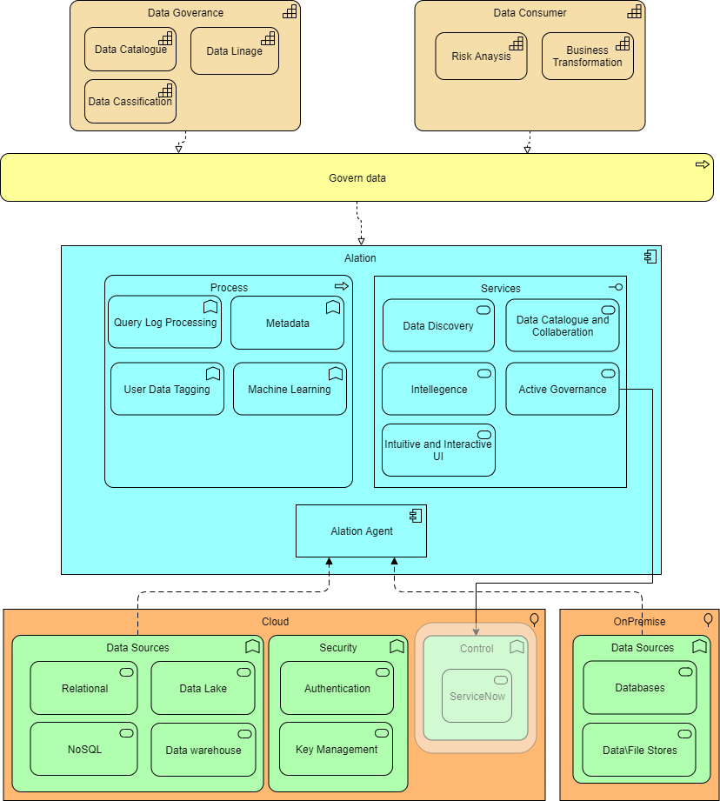
Diagram 1 Alation Cloud Service Capability Map.

Alation will provide the following capabilities.

Capability | Description
Data Discovery | - Collect data from various sources ensuring data integrity and quality  - Transform data into a suitable format.
Data Linage | - Track the lineage of data assets  - Maintain historical records of data changes  - Enable tracing data back to its source.
Data Catalogue and Collaboration | - Identify and classify data assets assign the appropriate data classification labels  - Manage data classification changes  - A centralized searchable data hub for all data.
Active Governance | - The ability to establish data ownership and stewardship roles  - Assign responsibilities for data management  - Develop and implement data access control mechanisms  - Develop, and enforce data governance policies and standards.
Intelligence | - Support the application of data tagging and Machine Learning techniques to the data and searches  - Allow collaboration within and across business units.
Intuitive and Interactive UI | - A google-like interface which is both intuitive and interactive.

And the following application processes.
Application Process | Description
Metadata | - Importing metadata from the identified data source.
Query Log processing | - A selection of database query logs to retrieve meaningful information about database objects extracted.
Machine Learning | - Suggesting business-friendly titles for technical metadata and terms for the glossary  - Refining the data catalog improving the quality to end users.
User Data Tagging | - Process enable user tagging on metadata objects.

  - Stakeholder Management
The following key stakeholders have been identified.
- Aegon Business Users – The users of the tool who fall into 2 main categories,
  - Data Consumers the end users of the tool who will use Alation to drive business analysis and goals
  - Data Management Team – Each business unit will have a data management team that is responsible for the unit’s data policy and user compliance.
- GTS Data Management – The team accountable for creating \ managing Aegon’s global data management policies and ensuring that compliance to them is applied across the toolset.

  - Baseline Architecture
Alation will replace the existing data management tool Collibra. Collibra is a SaaS service with collection agents in the Aegon Datacentres. The decommissioning of the Collibra service is included in this project.
Metadata data in Collibra will be migrated to Alation while the collection agents and supporting infrastructure will be decommissioned.

  - Teams Impacted
The following teams will be impacted.
- GTS Collibra Support team – Alation will replace Collibra which is currently supported by GTS. The Same team will support Alation. The support team will be provided with operational training on Alation ahead of the production release
- Business Users - The users in each of the business units will be migrated from Collibra to Alation during the implementation phase. This will be at the same time as the existing metadata is migrated. The migration project will provide guidance and training material for the business users.

- Requirements
  - Business Requirements
The key business requirements are high-lighted in the following table.
Business Requirement | Comment
An intuitive and user-friendly interface with a modern ‘google’ like search facility. |  | Requirement met
Users can easily determine where data is from, how it is being used, and intuitively view associated information such as columns, tables, transformations, queries, etc. |  | Requirement met
Supports a role-based access control model for users. |  | Requirement met
Allows users to identify and classify data depending on its relevance and suitability. |  | Requirement met
Provide users with an easy way to integrate, catalogue and track meta data in the hub. |  | Requirement met
Support the tagging of data with customizable values and identifiers. |  | Requirement met
Deliver a data catalogue that supports the continuous automated discovery of data sets across the business. |  | Requirement met

A full list of business requirements can be found in Alation Business Requirements
  - Functionals and Non-Functional Requirements
The key functional and non-functional requirements are outlined in the following table.
Requirements | Comment
There is a requirement to deliver a Data Governance tool as a GTS service to the Aegon Business Units | Requirement met
The Alation Service Model should be defined to outline a joint GTS\Business Unit operating Model | Requirement met (Section 8.7.3)
There is a requirement to ensure that Alation can connect to and pulling data from, Snowflake | Requirement met by use of Alation native connector outlined in (Section 8.6.3)
There is a requirement to provide a lineage capability | Requirement met by the Alation tool. (Section 6.1.1)
There is a requirement to ensure Data Quality | Requirement not met. Enablement of data quality will be provided by a separate tool currently being evaluated.
There is a requirement that the design must support a Silver Service SLA 99.0% (target) | Requirement met through SAAS (section 8.7.1) and AWS EC2 SLA. (Section 11)
There is a requirement that the supporting infrastructure is available to support the expected data volumes

- Architecture and design
  - Value stream maps
The value stream capability map for the Alation service is illustrated in the following diagram;
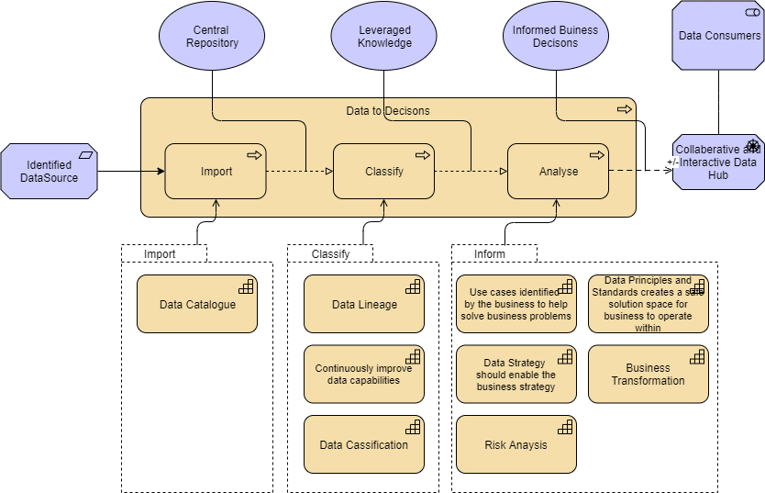
Diagram 2 - Alation Cloud Service Value Stream Map.

The value stream covers the Data to Decisions process that realises informed business decision through the 3 steps of Import, Classify and Analyse. Alation provides a platform with the capabilities that enable the business to make informed business decision driving transformations.

- Import – At the import stage of the process an identified data source will be imported into the Alation cloud service and catalogued for presentation via the data hub

- Classify – Through the classify stage, the platform supports the classification of the metadata captures lineage information and allows the data management team to improve the data presentation through features like user tagging and query log processing

- Analyse – In the analyse stage Alation cloud service brings capabilities that enable the data consumers to drive business transformation. Alation supports the analyse of data through business defined use cases, machine learning and analysis which in turn is aligned to the strategy, principles, and standards of each business unit. Analysis of the risk against the identified transformation is also possible in data hub.
Implementing the Alation with enable the realisation of a central data repository that is collaborative and interactive hub supporting the sharing of knowledge across all business units.

  - High level component design
The following diagram illustrated the proposed Alation cloud service deployment and its integration with Aegon data sources in AWS and in the on-premise data centres.

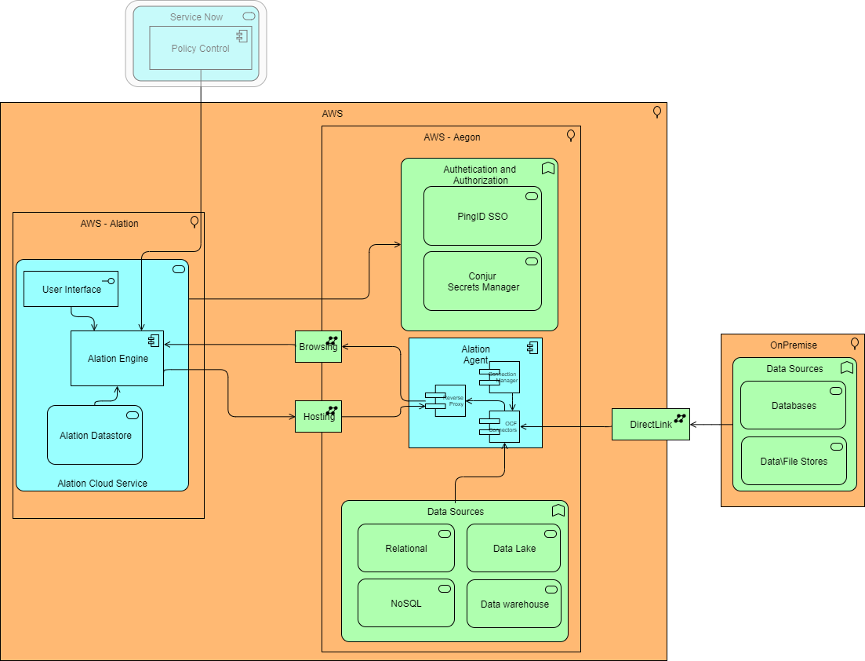
Diagram 3 – High Level Component View

The Alation Cloud Service consists of 3 components,
- User interface – The intuitive and interactive user interface used by Aegon users when accessing the service (The RBAC model is outlined in section 10.2 Role Base access)
- Alation Engine – The main application providing functions like the search capability, the ability to tag data and machine learning capabilities
- Alation Database – An RDS data base which host the metadata and the user customisation and tagging.

Traffic flow between the Alation cloud engine and the Agent in Aegon’s AWS will be over the internet using the GTS Cloud hosting and browsing services. The IP address of the Alation gateway will be whitelisted.

Signed certificates are used to encrypt the communication between the Alation Cloud and the Agent, one for the Agent and one root certificate. These certificates will automatically expire after one year and can be revoked via the console to stop communication. Certificates can be renewed at any time, whether they are current, expired, or revoked.

The engine will use the following services.
- PingID – The engine will be integrated with PingID to provide standard SSO.
- Secrets Manager - connects to Conjur Secrets Manager (inbound) to retrieve the DB credentials
- AWS data sources – The engine will pass on a copy of the relevant credentials to Alation agent to collect metadata
- Alation Agent – The agent collects the MetaData from the Data Sources and sends the data back to the Engine.

The Alation Agent will be deployed on a EC2 RHEL VM, in a dedicated segmented VPC in the Aegon AWS environment using the AWS Cloud Inspection/Segmentation Service for visibility and control.
Once it is passed the DB credentials by the Alation engine it will connect to the relevant data sources in both AWS and the on-premise data centres. This connection is agentless.

Note: Although ServiceNow is included in the diagram it is not part of the initial deployment and will be part of a future configuration / roadmap.

    - Data flow diagram
The following diagram outlines the expected data flows for the Alation deployment.

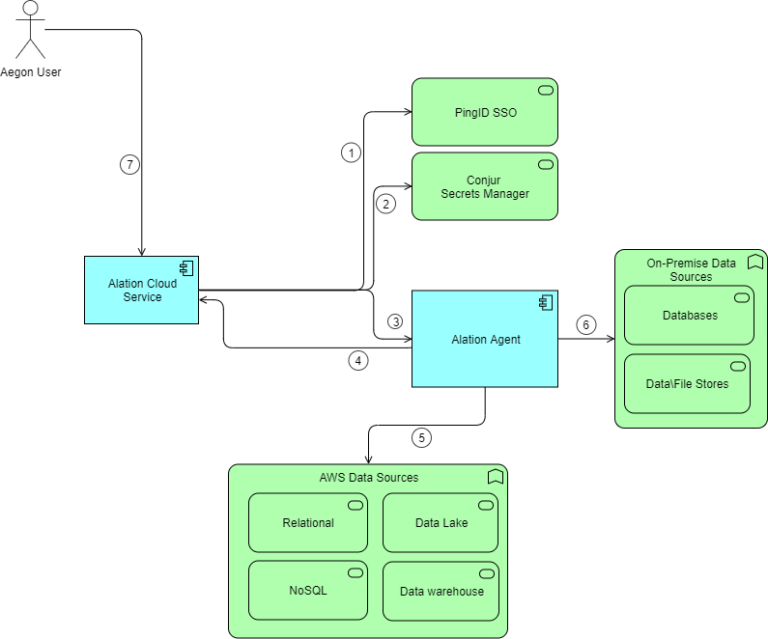
Diagram 4 - Alation Cloud Service Capability Map.

The Data Flows are described in the following table.

No. | Source | Target | Purpose | Protocol | Port
1 | Alation Cloud Service | PingID SSO | Authentication of Aegon users to the system | HTTPS | 443
2 | Alation Cloud Service | CyberArk Conjur Secrets Manager | To get data source connection credentials for the service | HTTPS | 443
3 | Alation Cloud Service | Alation agent | To pass a copy the data source credentials to the Alation agent. | HTTPS | 443
4 | Alation agent | Alation Cloud Service | Captured metadata is sent back to the cloud service from the Alation agent | HTTPS | 443
5 | Alation agent | AWS data sources | The agent pulls the metadata from the AWS data sources | Various | TBC
6 | Alation agent | On-premises data sources | The agent pulls the metadata from the data sources in the Aegon datacenter. | Various | TBC
7 | Aegon User | Alation Cloud Service | Browser based access to Alation and the user interface. | HTTPS | 443
Note: Protocol and Port for connecting the Alation agent data source will be documented in the detailed design.

  - Data Volumes
The volumes of data exported to Alation are not expected to change significantly from current data extracts to Collibra.
An assessment of the volumes for each data source will be part of the connector assessment in the project implementation. This will include initial data export and the expected rate of change.

  - Patterns Used
The following standard patterns have been used support the deployment of the Alation Cloud service.

- PingID SSO – Integration with Aegon single sign on service to support user authentication
- Cloud Browsing Service – accessing internet resources from private cloud environments.
- Cloud Hosting Service - demarcation and security controls for web hosted application services and provides security controls for internet accessible resources hosted in cloud environments
- Cloud Inspection and Segmentation Service – provides visibility, segmentation and advanced security for traffic flowing between VPCs, VNETs, CSPs and DataCenters.

  - Role Based Access Control
Alation will be integrated with Aegon IAM systems to provide.
- Authentication – Single Signon via PingID
- Authorisation – through Active Directory group membership
- Roles – Group Membership will be used to create different roles such as (Creator and Viewer).

    - Authentication
Alation Cloud Service will be federated with PingID the Aegon Single Sign On tool. Connection will follow the standard pattern SAML 2.0.
The Alation agent will use credentials stored in CyberArk Conjur to authenticate to data sources using unique credentials for each data source.
The Alation Engine and Agent authenticate to each other using a unique certificate and the use of whitelisted IP Addresses.

    - Authorisation
Authorisation controlling access to Alation, and the data will be via groups in the corporate Active Directory.

    - Roles
One principal of the Alation deployment is to enable the business units to manage and curate their data catalogs with minimal reliance on the GTS. Roles will be deployed to support this model.

Roles in Alation are classed either as a Creator or as a Viewer.
- Creator – The role that generates content, curates’ data, runs queries and configures / manages the data catalog. There are a number of sub roles available within creator such as Server Admins, Catalog Admins, Source Admins and Stewards
- Viewer – A general role aimed at users who occasionally search and browse data. Users in this role can collaborate though conversations. They cannot create new objects or edit fields.

The Creator - Server Administrator role is reserved for GTS. Users in this role are able to manage the SaaS service, creating groups, configuring the application and oversee backups and restores.

Each Business Unit deployment is expected to have at least the following roles
- Creator Catalog Admins - can create and edit Catalog objects; manage Data Sources as Data Source Admin; have access to group management, catalog customization, and Compose
- Creator Source Admins - Manage Data Sources, create and edit articles, edit fields on catalog pages, and use Compose
- Creator Stewards - can create and edit articles, edit fields on the catalog pages, and access Compose.
- Viewer – Read only role.
Note: Additional creator roles such as composer and explorer can be deployed if required.

Each of roles will have a corresponding group in Active Directory. Each Business Unit will have its own set of ‘Role Groups’. Details of the groups will be documented during the implementation.

  - Metadata and Alation Connectors

    - Metadata
Metadata is information that describes the structure, content, and usage of a data sources. Examples of metadata types that will be imported into Alation include.
- Descriptive information - Information on title, purpose, creation date, and creator. It’s useful for cataloging and discovering data, and identifying which data is most appropriate for use
- Structural information - How data is formatted, with information on tables, pages, types, and relationships. It’s useful for understanding how data is organized, determining if it can be combined with other data, and enabling relevant data discovery
- Administrative information- Access permissions, locations, file size, and ownership information. It’s useful for data governance, compliance, controls, and data management
- Reference information. Information on quality, sources, processes used, schemas, and formulas. It’s useful in determining how data can be utilized.

Note: Details on the specific metadata captured per data source will be documented the operational documentation set. This will include an assessment of the security and expect data volumes.

    - Catalog Sources.
A source is an object that documents the connection to a data store to identify and extract metadata.

There are 4 main source types that Alation can connect to extract metadata.
- Data Source – Typically a database connected using built-in JDBC drivers
- Virtual Data Source – A database type that Alation does not offer a native connector or cannot be access due to policy restrictions. Metadata can be accessed via API or a manual import
- File System – Data on files systems is documented and catalogued using the File System source
- BI Server – Alation developed connects supports the connection to servers (BI), reports and dashboards.
Note: Additional conceptual object like glossaries, terms, policies, data products can be added as required by the business units.
.
    - Connectors
It is expected that the Alation deployment will provide the ability to connect to the following Aegon data stores.
Connector | Source Type | Metadata Extraction | Table Sampling | Query Log Ingestion | Lineage | Column Level Lineage
Glue | Data | Y | N | N | N | N
Oracle | Data | y | Y | N | y | y
PowerBI | BI | Y | N\A | N\A | Y | N\A
Redshift | Data | Y | Y | Y | Y | Y
S3 | File System | Y | N\A | N\A | N | N\A
Salesforce | Data | Y | N | N | N | N
ServiceNow | Data | Y | Y | N\A | N | N
Snowflake | Data | Y | Y | Y | Y | Y
SQL Server | Data | Y | Y | Y | Y | Y
Tableau | BI | Y | N\A | N\A | y | N\A
Notes:
- BigID have a customized connection that will be deployed during the implementation
- A QuickSight connector is on the Alation roadmap and will be delivered in 2024
- Glue lineage is on the Alation roadmap and will be delivered in 2024
- Additional connectors are available on request. A standard approach will be developed to support adding new connectors / data sources.

Authentication
As well as basic authentication (username and password) Alation connectors also support specific authentication methods such SSL, Kerberos, and LDAP. The authentication method is dependent on the connector and source systems and will be fully documented during the implementation phase in the Detailed Design.

  - Service Model

    - Service Description
Alation will be a common service delivered and managed centrally by GTS. It is classified as a silver service with the service level agreements highlighted in the following table.

​ | Platinum​ | Gold​ | Silver​ | Bronze​
Design Target Level​ | 100.00%​ | 99.90%​ | 99.50%​ | 99.00%​
Availability​ | 99.95%​ | 99.90%​ | 99.00%​ | 97.00%​
Latency​ | 99% < 450ms​  90% < 900ms​ | 99% < 900ms​  90% < 1800md​ | 90% <900​ | ​
MTTR​ (Mean time to resolution) | 15 min​ | 60 min​ | p1 - 4h​ | 2 days​
 |  |  | p2 - 12h​

Performance Metrics
The following performance metrics are expected for the service
- Alation Cloud – Alation Cloud will be licensed to support 500K objects in the first instance.
- Alation Agent – the deployed infrastructure (a single agent) is capable of supporting the capture of 15 million objects per data source. Additional Agents can be deployed on a

    - Data Tooling Working Group
The monthly Data Tooling Working Group includes representatives from all BUs. This is a forum for BUs to raise challenges or demonstrate efficiencies in how they use the platform.
This could be a business process related to workflows, general ways of working, tagging CDEs, bulk updates, etc. The aim is to avoid duplication in Alation, and indeed in efforts, and for other parts of Aegon to benefit from shared knowledge.
BUs can also request support via ASK where GTS SMEs will assist and, where appropriate, any learnings will be shared back to the working group.
An additional responsibility of the working group will be to ensure Alation is aligned with Aegon’s data management policies and security frameworks. This will include the management of change to the policies / frameworks.

    - Operational model
Core users will be given a large amount of freedom within Alation; the restrictions on roles, permissions and workflows ensure that the system continues to behave as others expect it to. The proposed operating model will be based on tasks defined as either having a Global, Local and Joint responsibility.

The proposed operating model is illustrated in the following diagram.
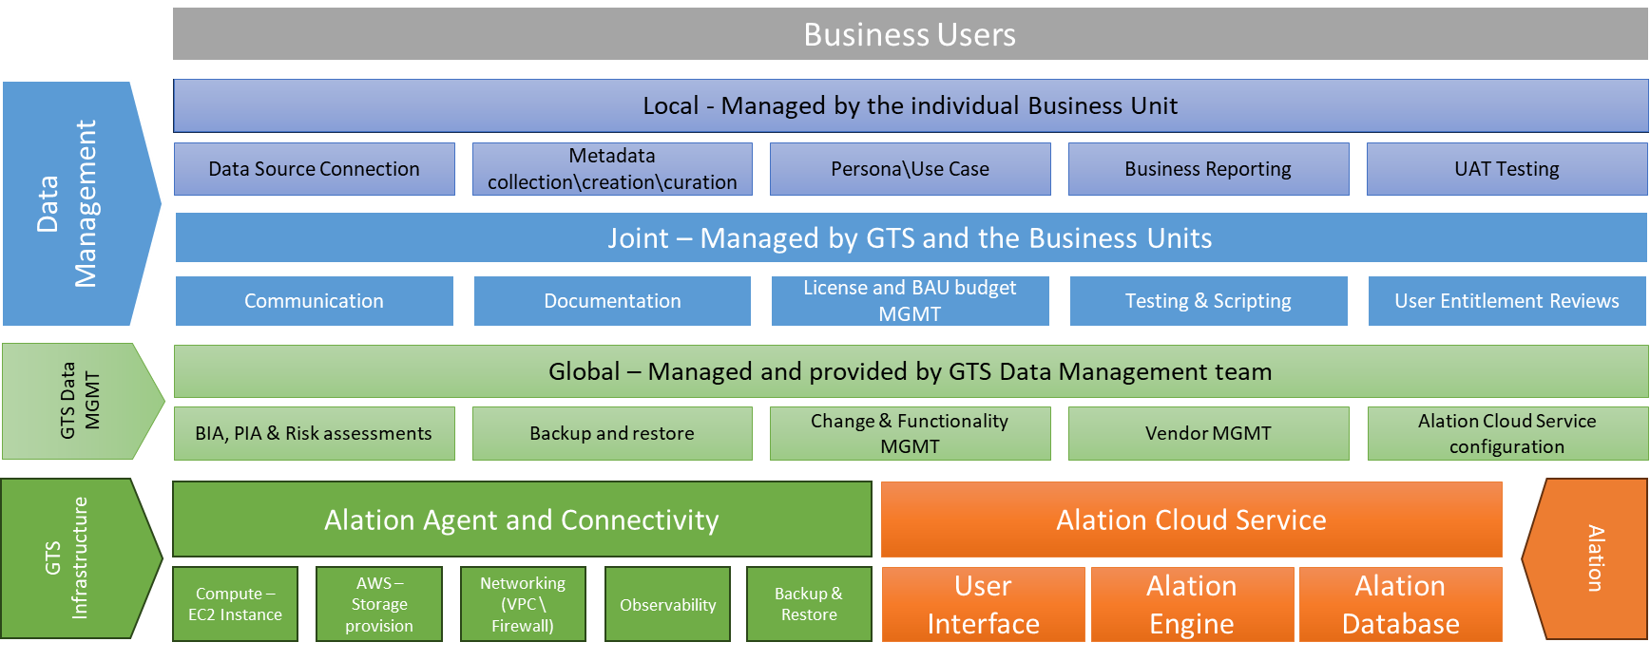
Diagram 5 Alation Operating Model

The Alation Cloud service and Agent is delivered by Alation as a SaaS. GTS infrastructure team provide support for compute, storage, networking, backup and restore and observability for the agent, EC2 instance and the network in AWS.

The configuration and management of the Alation Cloud Service will be global and delivered by the GTS data management team, while data management will be split between joint business unit and GTS and local where the individual business units are responsible.

Global – Managed and provided by GTS have been defined as
- Application access provisioning - connection to the application via SSO & AD Groups
- Application versions are up to date and in support
- Architecture overview and future solutions
- Arrange for resolution for functional problems (including root cause analysis)
- Backup and recovery
- Compliance to IT Control Framework (IT Controls Only)
- Create and resolve technical problems (eliminate underlying causes of incidents)
- Create problem tickets for functional problems
- Ensuring all functional Changes are approved prior to moving to production
- GTS change process for application updates
- Implementation of patches and version updates
- Manage and maintain infrastructure and console configuration
- Resolve technical incidents (restore service/function in line with SLA)
- SLO report and meeting CS and Business
- Unit testing (individual component testing)
- Update BIA and Risk Assessment
- Update PIA
- Vendor management
- Work functional ASK tickets and create a change ticket for each change, including Configuration Item.

Local - Managed by the individual Business Unit have been defined as
- Connection to BU data sources
- Create ASK ticket for new functional/report requests originating from the Business
- Management and configuration of BU data sources within the application
- Metadata collection/creation/curation
- Persona or use case specific views
- Report incidents via incident management process
- UAT testing.

Joint – managed by GTS and the Business Units
- Communicate to end-users
- Create/maintain technical and functional application documentation
- License management
- Manage IT BAU budget and expenses
- Regression testing
- User entitlement review within the application
- User scripts developments (e.g., API, workflows).

System Admin Level Changes
Changes requiring System Admin level permissions should be requested via ASK. Any changes that may impact other BUs will be reviewed by GTS SMEs and/or the Data Tooling Working Group members before implementation. Lead times for implementing such changes in production are expected to be around two weeks due to the requirement to review.

- Risk
  - Exemption requests
No Exemptions have been requested.

  - Data Classification
The Alation service has been classified with.
- Data Confidentiality Classification – Internal
- Data Legal and Regulatory Classification - Personal Identifiable Information.

Note: A PII classification is due to the storing of Aegon employee details (username, email and the data creator\owner details). The service will not access or store any Aegon customer information.

  - Data Sovereignty
The Alation Cloud Service will be deployed in two regions to ensure that data sovereignty compliance is maintained
- US – The current Transamerica deployment is located the US region
- Europe – A new European deployment of the Alation cloud service will be in the European region.
Note: Agent separation and firewall policies will be used to ensure that data is kept in the correct location.

  - PIA
A PIA (privacy impact assessment) 10509 has been submitted in Onetrust and is currently in review (link).

  - Risk Assessment
Two risks have been identified and will be managed by the implementation project.
- There is a risk that the project will not complete the migration of existing data from Collibra before June 2024 resulting in additional support and license costs
- There is a risk that the required resources will not be available to support the implementation timeline resulting in project delays.

- Security
  - Conjur Secrets Manager
Alation Cloud Service connects to the Aegon Data sources using a defined username and password which is stored in the Aegon’s Conjur Secrets Manager service. The credentials are passed to the Alation Agent which uses them to connect to the data source. As outlined in section 8.6.3 Connectors, each agent connector has different capabilities and a number can do table sampling and / or query log ingestion.
Each connector will be assessed and enabled during the implementation phase. This will include a security assessment of the connector capabilities to limit the access to PII information. The intention is that access to the non-authorized data will be prohibited by the access rights of the connector username.

  - Threat model
    - Security Boundaries
The security boundaries are outlined in the following diagram. Each boundary is marked by the red line.
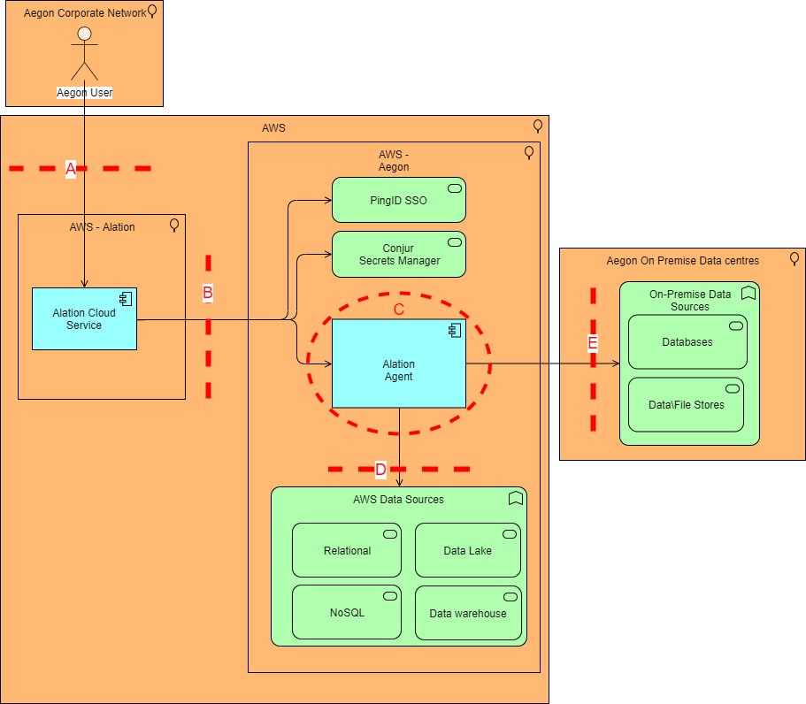
Diagram 6 – Alation Threat Model with Security Boundaries

Five security boundaries have been identified in the proposed solution.
- A – User Interface – Internet based access to the Alation Cloud service. Used by Aegon Users
- B – Cloud Hosting and Browsing Service –Traffic crossing this boundary will be sent to the inspection VPC with incidents and alerts being send to the Aegon SOC
- C- Segmented VPC - The Agent will be deployed on a dedicated segmented VPC s and all incoming data will be sent to the inspection VPC and Aegon SOC (if required). Outgoing data will not be sent to the inspection VPC as it be inspected as it crosses boundary B.
- D & E - Alation Agent to data sources – Metadata captured from the Aegon data sources crosses these boundaries as it is captured by the Agent.

    - Additional Security Measures
The Alation Cloud Service has three additional touch points with Aegon Services, Federation with PingID and Conjur Secrets Manager.
- PingID – This is the standard pattern for user authentication and requests will be send to the inspection service
- Conjur Secrets Manager – Usernames and passwords for access to the metadata will be stored in Aegon’s Conjur Secrets Manager service. All requests by the Alation Cloud service for credentials will also be sent to the inspection service
- User Access – Users will connect to the Alation Cloud service using the Aegon Internet proxies. Traffic will be inspected as per standard.

    - STRIDE Assessment
Aegon use STRIDE threat modeling methodology (or method) to assess the security threat to services. It is a mnemonic of six types of security threats. Each letter of STRIDE stands for one of the six types of security threats:
- Spoofing
- Tampering
- Repudiation
- Information Disclosure
- Denial of Service
- Elevation of Privilege.

The initial STRIDE assessment of the proposed Alation deployment is outlined in the following table.

Note: At this stage only boundaries A & C were assessed. B is two standard GTS services and an assessment of boundaries D & E will be completed during the implementation phase as part of a connector review.

STRIDE | Identified Threats  A – User Interface Access | Identified Threats  C - Alation Agent
Spoofing | Access to the Interface is via HTTPS and Internet facing  Access Authentication is via Aegon’s PingID. | The agent is within Aegon’s data centre boundaries and upgrades are within Aegon’s control.  Therefore, no spoofing threats have been identified.
Tampering | Users with elevated permissions would be able to delete connectors metadata and users. | The agent is capturing metadata from data sources and is not capable of tampering with the data
Repudiation | Task and Access request are logged and Aegon access is read only. | No Repudiation threats identified.
Information Disclosure | There is a potential threat that a user could access unauthorised data (i.e., cross BU). Control is managed via the RBAC model at a global and local level. | There is a potential threat that restricted PII data could be pulled from the data sources and imported into the Alation Cloud service.  This is limited to certain connector and will be assessed in implementation as part of the connector assessment review.
Denial of Service | Potential to disrupt user access via invalid login credentials.  Impact considered low as Alation is a silver service. | Ther frequency of Agent sample requests can be managed to mitigate against a potential DOS impact on the data source. Sampling frequency can be either on demand or via a scheduled task and will be documented during the connector assessment review.
Elevation of Privilege | No elevation threats identified. | There is a threat that elevated privileges could be accessed and the agent could pull restricted PII data into the Cloud service.  This will be managed through the connector username permissions documented during the connector assessment review

Note: Further threat model workshops on the proposed Alation deployment and security boundaries will be documented in the detailed design.
- Solution Design
Technology
Alation Cloud Service (SaaS)
Alation Agent
AWS Network (dedicated VPC, IP Whitelisting)
AWS EC2 Instance
Solution Breakdown
Alation Cloud Service
An Alation Agent used to pull data from Aegon Services. Deployed on an GTS standard AWS host EC2 Instance (RHEL v9.x). Secured to GTS standards.
Alation cloud service to Agent connection using Cloud Hosting service with IP whitelisting
Agent to Alation cloud service connection using Cloud Browsing service with IP whitelisting
The Alation Agent will be in a dedicated segmented VPC
Use of the Ping Identity SSO Solution to provide employees with a single point of entry to the platform.
Leverage Active Directory groups for permissions to ensure users can only access products/materials relevant to their job functions/business line.
Use of a public Internet connection (HTTPs over port 443), for users to connect to via standard GTS internet connectivity. Requirement to ensure that Alation portal is added to Aegon Whitelist.
Fault Tolerance (Resiliency, High Availability, Disaster Recovery)
Alation is a SaaS service with target SLA of 99.99%
The Alation agent will be installed on a EC2 instance with target SLA of 99.95%
Backup Strategy
Backup / Restore facility is provided by the solution provider. Frequency and restore requests can be controlled by Aegon.
The Alation agent EC2 instance will be backed up as per GTS standards.
Encryption and Security
Data in flight from the Alation agent to the Alation Service is encrypted via SSL TLS1.2 as a minimum.
Data in flight from the data source to the Alation agent will be assessed and documented during the implementation phase.
Access to the Alation portal is via HTTPS.
Monitoring and Observability
Alation have a dashboard (Alation Cloud Service) which provides real-time information and updates for the service. Information on the status page includes on the cloud status, incidents (including resolution) and planned maintenance.
The Alation agent on the AWS EC2 instance will be monitored via the standard GTS observability platforms (Neptune and Splunk) with incidents being raised within ServiceNow.
Data Residency
Aegon’s European metadata imported into Alation will resides in Europe
Aegon’s American metadata imported into Alation will resides in the US
Exit Strategy
Replacement efforts would take 1-12 months at an expect cost of <1million. There are 3-5 rival suppliers providing similar solutions
- Infrastructure Breakdown
  - Standard Components
The following standard components are used in the deployment.
Standard Ref | Purpose | Configuration | Additional Details
SSO PingID | User Authentication | Federation with PingID | SAML 2.0
CyberArk Conjur Secrets Manager | Data Source connection credentials | Alation Cloud Service connection to Conjur | API (HTTPS)
014 Cloud Hosting Service | Access from Alation Cloud to AWS hosted Agent | Whitelisting of IP addresses | Exchange of certificate to encrypt traffic between cloud and agent
019 Cloud Browsing Service | Access from AWS hosted Agent to Alation Cloud | Whitelisting of IP addresses | Exchange of certificate to encrypt traffic between agent and cloud
Segmented VPC | Dedicated VPC to host Alation Agent VM | Standard VPC configuration | -
EC2 – Linux | Virtual Machine to host the Alation Agent | Large (Minimum – 4 vCPU, 16GB RAM, 40GB HDD) | Red Hat version 9.x (x86 64-bit)

  - Delivery Teams
The GTS delivery teams impacted by the implementation are.
Delivery Team | Requirements | Additional Details
Network | - IP whitelist configuration  - VPC Deployment  - Firewall configuration.
Windows | - EC2 Deployment and Agent install.
Active Directory Team | - Federation Implementation  - Active Directory OU and Group implementation.

Key Design Decisions and Concerns
No decisions or concerns have been identified at this stage.
Decision or Concern | Driver | Impact | Required Action | Owner
- Architecture Alignment
All systems, versions, and configurations are within GTS supported architecture and versions at the time of this document creation.

This SaaS deployment aligns with GTS’s cloud first strategy and adheres to the approved SaaS Reference Architecture.

- Estimated Costs
  - Alation Cloud costs
Alation Cloud Service
The Alation cloud Service costs for the next 3 years are outlined in the following table.
 | 2024 | 2025 | 2026
Alation (Global Solution) | $164,584 | $194,000 | $194,000

Alation Migration Services
The use of Alation Migration services to migrate the existing Collibra hosted metadata will be $36000.

License Costs
The proposed Alation service has the following licenses
- Creator – 46
- Viewer – Unlimited.
Additional Creator licenses can be bought if required.
- Implementation Approach
  - Implementation Options
N/A at this stage

  - High Level Activities
The implementation project will follow the following high-level activities.

- Alation will Create a Aegon EU Instance
- Initial Active directory groups will be agreed – (GTS and Business Units)
- Implementation of AWS Network Configuration
- Deployment and testing of Alation Agent
- Details assessment of each data source connector (security, metadata and volumes)
- Migration of Data from existing solution to Alation
- Documentation and creation of detailed Service Model
- Decommission of Collibra service.

  - Implementation Assumptions
Access to Conjur secrets is supported for 3rd party SaaS services.

  - Proposed Level of Coordination
N\A at this stage.
- Vendor Diagram
An alternative vendor view of the High-level component design is illustrated in the following diagram.
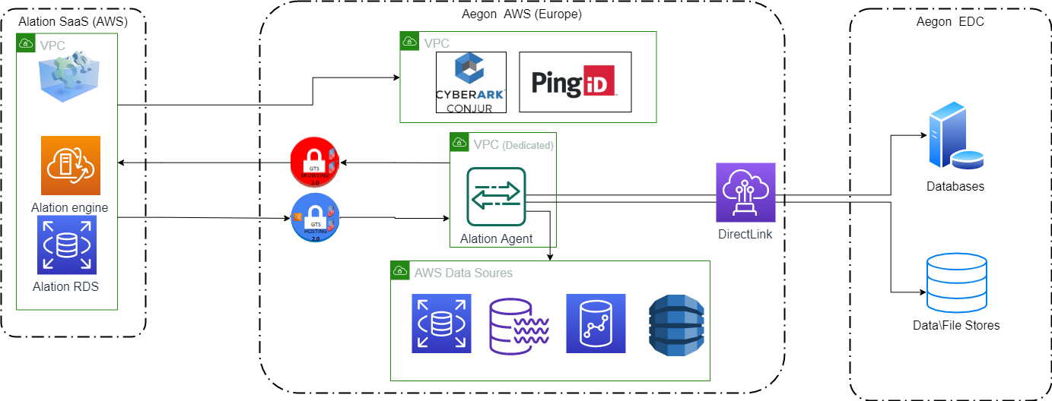
Diagram 7 – High Level Component View - Vendor

Data Classification (ITCF Definitions)

